David Thomas

3-tier:

User interface

* MainView class

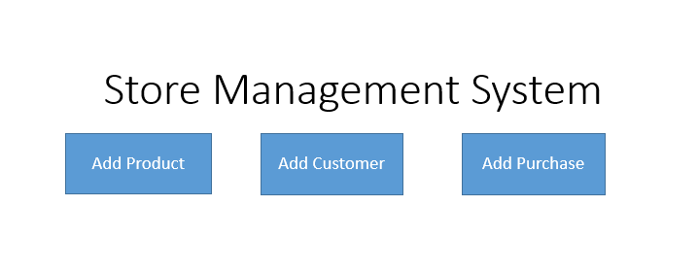

* AddProduct class

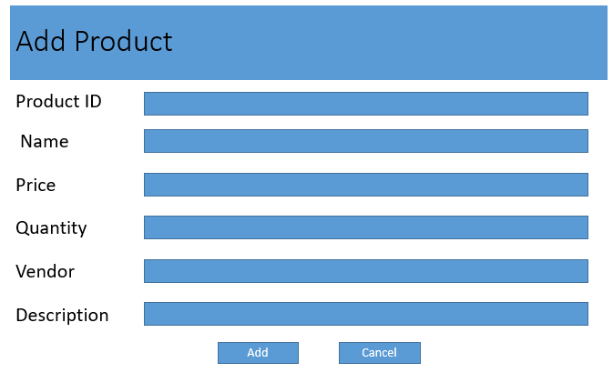

Business Logic

ProductModel class: store information of a product

AddProductController: process events of AddProductView

StoreManager: main application object

Data Access

* SQLiteDataAdapter class: read/write data